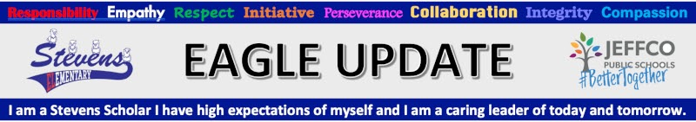
Office 303-982-2198 Attendance Line 303-982-2198

Aug 13-15 | -Wheatridge Carnation Festival https://thecarnationfestival.com/  -If you would like to join Stevens Crew Float in the Parade on Saturday morning, meet us at 8:30am, South of 38th on Chase St. We are #36.
Tues 8/17 | -Orientation required for all students - NEW INFO BELOW  -4pm-6pm, BETTER TOGETHER BBQ - Be prepared for BIG FUN and YUMMY FOOD!
Wed 8/18 | First full day of school, see schedule below
 | Printable Stevens Family Calendar
Tuesday, August 17
Updated! Orientation Information - All students will enter and leave through the cafeteria doors, just East of the front doors, near the bike lock area. Staff will be there to greet students. Please come for the session you signed up for.
Morning Crew orientation - 8:00am-11:00am
Afternoon Crew orientation - 12:20-3:20pm
During orientation students will get a tour of the school, review safety measures, drop off school supplies and start to build relationships and, for some, reconnect with their teacher and classmates.
Lunch will be provided for any students who would like to eat at school this day.
Morning Crew, will eat from 11:00-11:20
Afternoon Crew will eat from 12:00-12:20

Don’t miss our Better Together Back to School BBQ - Tuesday August 17, 4:00-6:00pm. We have some really fun stuff planned and can’t wait to welcome all of our Stevens Families back to school. This will be an outdoor event on the front lawn for all Stevens families and staff.

Wednesday, August 18

NEW! FIRST FULL DAY OF SCHOOL
- 8:00am - ALL students will enter school through the cafeteria doors. (East of the front doors near the bike lock area.)
- Please don't drop students off anyway before 7:55am as there is no supervision before 8am.
- Breakfast is free for students who wish to eat at school.
- Lunch is also free for all students
- 8:20am - Tardy bell rings, students arriving late must sign in
- 3:20pm - School ends for the day
Stevens School Supply Lists
School Fees can be paid online through Jeffco Connect - look for the link when you are updating your account.
Fill out your Free and Reduced Meal Application www.SchoolCafe.com. This link is also in Jeffco Connect. Why should you apply? See important information below.
Why Free & Reduced Meal Applications for All Families? Jeffco is proud to be able to continue offering free meals to all students this year. However, school meal applications are good for more than just free meals.
Benefits for your student and family and Benefits for your school
For questions or support with applying, please contact our Family Liaison, Anita DeLeon anita.deleonbannister@jeffco.k12.co.us.
Updated - Mask requirements
- Preschool students must wear masks while inside
- Elementary students must wear masks while inside
- Unvaccinated staff must wear a mask
- Vaccinated staff - recommended masking
- All visitors and volunteers to the school, any age, vaccinated or not, mask is required
New info added: Jeffco Schools Health protocols for 21-22
Enrollment is ongoing
Please see the Jeffco Registration Checklist for instructions. For help or questions call or email Vicki Zeimen 303-982-2198 vicki.zeimen@jeffco.k12.co.us

NEW! Code of Conduct (Student & Family Handbook)
The Code of Conduct for the 2021-22 school year is posted on the Jeffco website. Translated versions will be posted soon. Lots of good information here about expectations for our students.

Jefferson County School District R 1 would like to continue connecting with you via email. If you prefer to be removed from our list, please contact Jefferson County School District R 1 directly. To stop receiving all email messages distributed through our SchoolMessenger service, follow this link and confirm: Unsubscribe
SchoolMessenger is a notification service used by the nation's leading school systems to connect with parents, students and staff through voice, SMS text, email, and social media.

CAUTION:This email originated outside of the organization. Do not click links or open attachments unless you recognize the sender and know the content is safe.
From: bounces@spe.schoolmessenger.com

